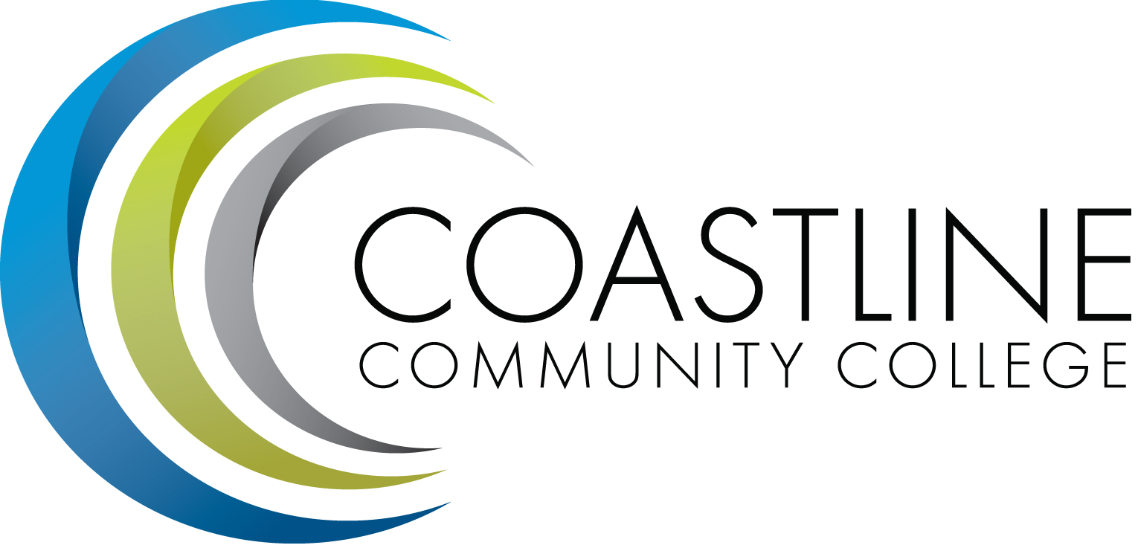

Budget Committee
Wednesday, March 14, 2018
1:00 p.m. – 3:00 p.m.
College Center – Fourth Floor Conference Room
AGENDA
Committee Mandate: To identify resource allocation based on the mission, plans, and goals of the college as articulated in the Education Master Plan (EMP) and as developed and recommended by the Planning, Institutional Effectiveness and Accreditation (PIEAC) committee.

CALL TO ORDER
  - Welcome
  - Adoption of Agenda
  - Approval of Minutes: February 14, 2017

REPORTS
  - 2018-19 Preliminary Budget Development – A. Dunn
  - 2017-18 Projected College Ending Balance – H. Rothgeb

DISCUSSION
  - Budget Model Discussion Guide –A. Dunn
    - CCCD Final 2017-18 Budget Allocation Model
    - Admin 9 Expenses
  - 2018-19 PIEAC Prioritized Funding Requests – C. Nguyen

ACTION
Follow-up items from February 14 meeting:
  - PIEAC Expenditure Year To Date – H. Rothgeb
  - Non-Credit and Enhanced Non-Credit Courses Listing – V. Rodriguez

ANNOUNCEMENTS
5.1 Next Meeting: April 11, 2018, 1:00-3:00 p.m., CCC 4th Floor Conference Room

ADJOURNMENT

Attachment provided via email and at meeting

